**Landing, Login, and Enrollment Pages Development**

Jaime Aviles

University of Arizona Global Campus

CST 499

Doctor Amr Elchouemi

1/10/23

**Introduction**

Creating a dynamic website that connects to a MySQL database requires the use of several key technologies. The first step in this process is to properly set up and configure a web server, such as Apache. This will allow the website to be accessed by users through a web browser. In addition to the web server, a database management system such as MySQL is also necessary for storing and organizing data. Finally, a programming language such as PHP is required to create the necessary scripts and functions that will allow the website to interact with the database and provide users with a more interactive and personalized experience. Properly preparing these technologies is essential for building a successful dynamic website that can effectively connect to a MySQL database.

**Explain How to Run a PHP File in XAMPP**

Running a PHP file in XAMPP is simple. Once the application is installed, launch the XAMPP control panel and start the Apache and MySQL modules by clicking on the “start” button on the right side of the window.

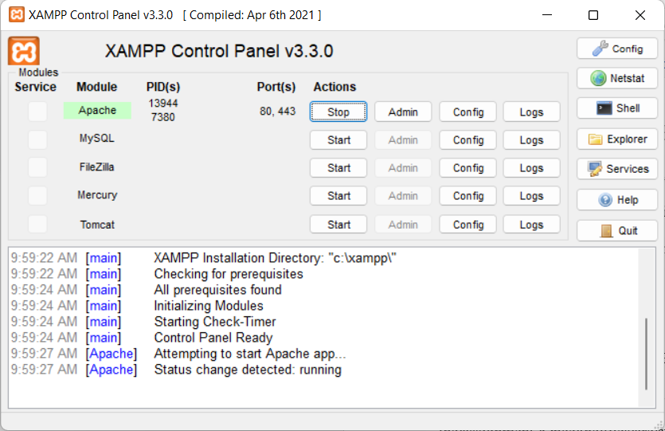

Then, navigate to the "htdocs" folder within the directory where XAMPP is installed and place the PHP files there, or create a separate folder for the assignment and install the files there. Once the files are stored, open a web browser and enter either "localhost" or the IP address followed by the directory of the stored files into the address bar. Note that the "htdocs" folder does not need to be included in the address bar (Mikoluk, 2013).

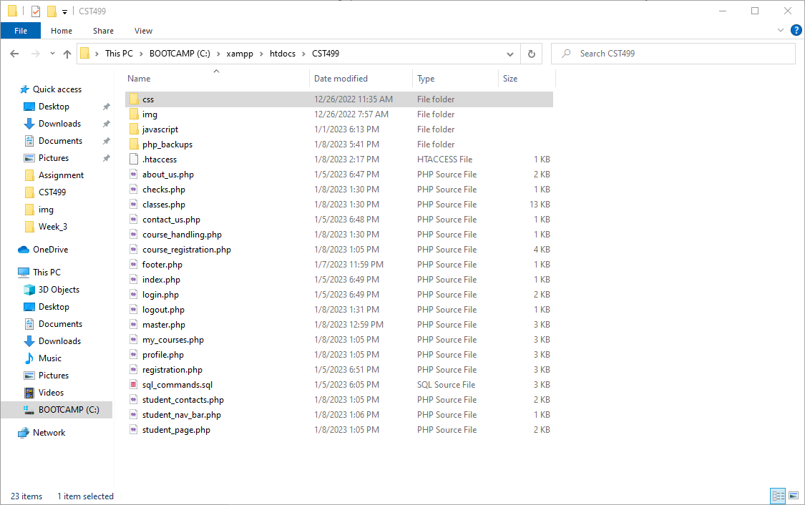

Directory above/ Address bar with link to directory below



MySQL with project database and tables below

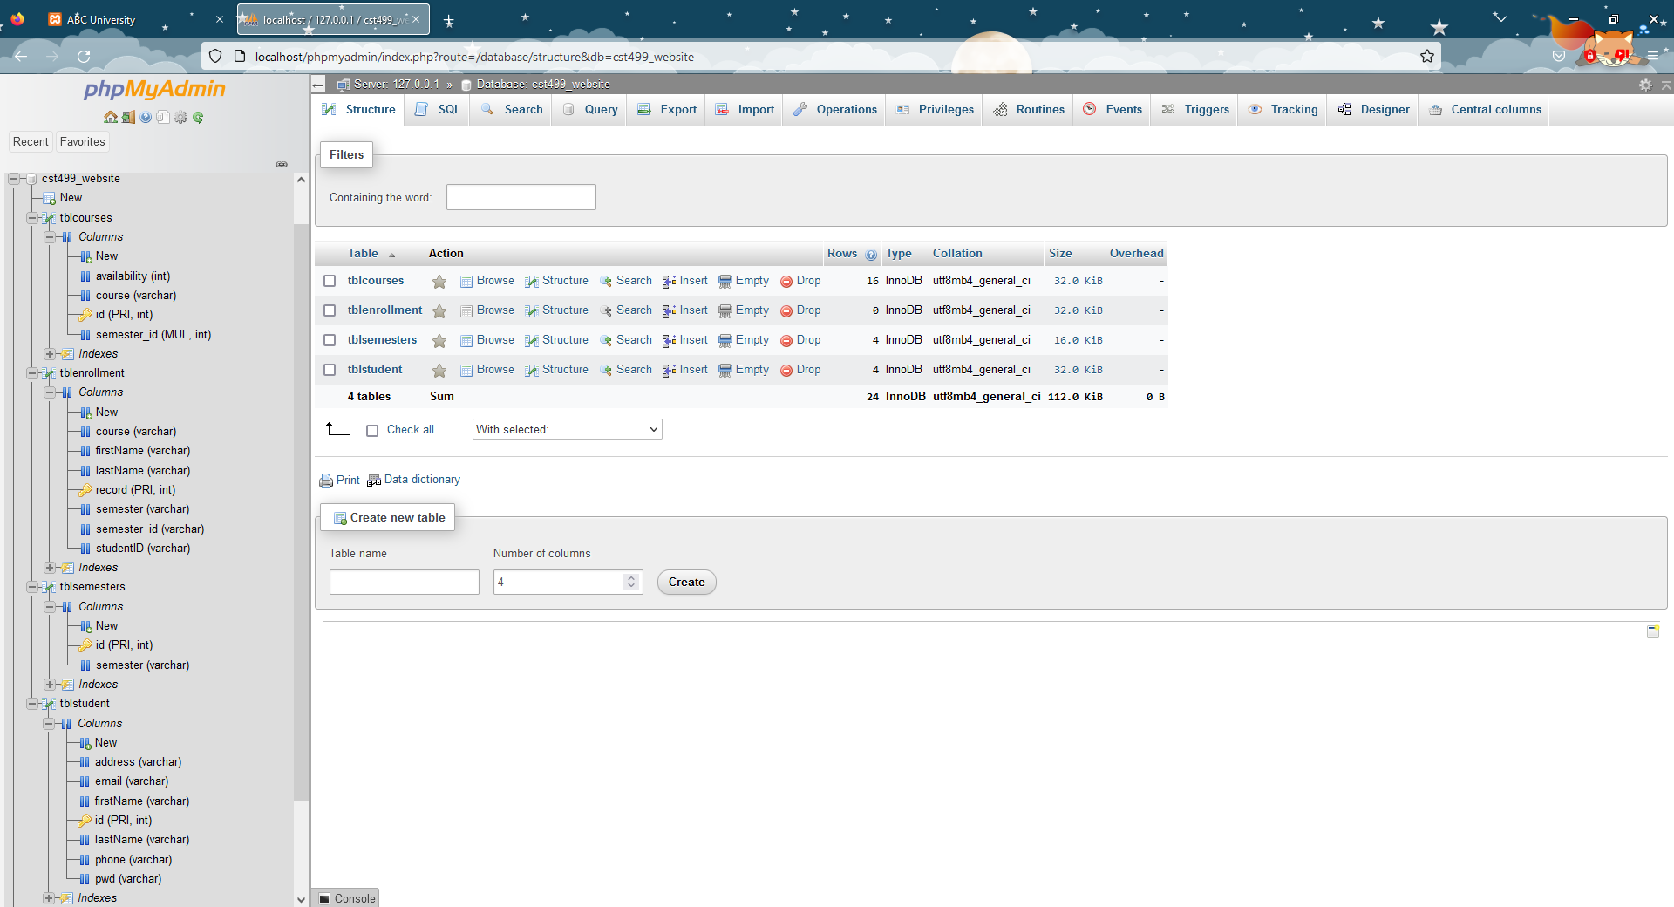

Code for the creation of the database, tables, and fields below

-- Create Primary Database

CREATE DATABASE cst499_website;

-- Create table for students

CREATE TABLE tblstudent (

id INT NOT NULL AUTO_INCREMENT PRIMARY KEY,

firstName VARCHAR(255) NOT NULL,

lastName VARCHAR(255) NOT NULL,

address VARCHAR(255) NOT NULL,

phone VARCHAR(255) NOT NULL,

email VARCHAR(255) NOT NULL,

pwd VARCHAR(255) NOT NULL

);

**Discuss the MySQL database functions that you used and the steps you took to create the database connection custom class**

I used several MySQL database functions to create a custom database connection class. Firstly, I created a class called “dbConnect” and created a function called "mysqlConn" function to establish a connection to the MySQL server. This function requires the server hostname, username, password, and database name as arguments. The function the assigns a variable named “$con” ad uses the mysqli_connect to establish a connection to the database. If there is an problem in connecting to the database, the php “die()” and “mysqli_connect_error()” functions will handle any errors that may occur during the database connection and query process. This function returns a string describing the error, or an empty string if no error occurred (*PHP Mysqli_Connect*, n.d.). If there are no issues, the “$con” variable is returned to a calling code. By using these MySQL database functions, I was able to create a custom database connection class that allowed me to easily connect to the MySQL server and execute queries on the desired database.

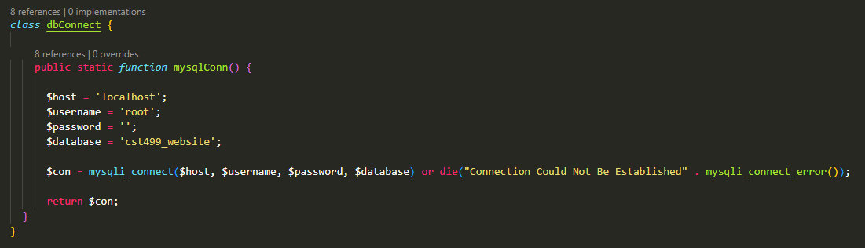

The database connection class above

**Explain the Steps Taken to Create the Registration Page and Saving the User Information in the Database**

To create a registration page and save user information in the database, we first added form elements to the PHP code that would allow us to create actionable behaviors. These form elements included the action attribute, which defines the code to be executed, and the method attribute, which specifies whether to use the POST or GET method. Next, we added labels and input types to the form for the first name, last name, address, phone number, email address, and password of the user. Labels are used to display the field type, and only require a "form" attribute

to match with the input type. Inputs, on the other hand, are used to collect user information and require "type", "name", and "required" attributes. After this, we added a button element to the

form with "type", "name", and "id" attributes. The "id" attribute is used to define actions in the code that will submit data to the MYSQL database.

To complete the process, we call to the “checks.php” where an "if/else if" statement is used to verify that the "register" button was pressed and the method was "POST" via the “isset()” function. If the POST is confirmed, the studentRegisterclass is called and the function setRegistration() is used to register the student into the database. The class also calls to the "dbActions" class with the “mysqlConn” function to check submitted data, query information from the database, and check query results (Connolly & Hoar, 2018). Finally, we conducted testing using dummy information and found that all actions were completed successfully. In the event of errors, such as missing fields or a lack of database connection, the page would return to the registration page with blank fields and an error displayed in the address bar.

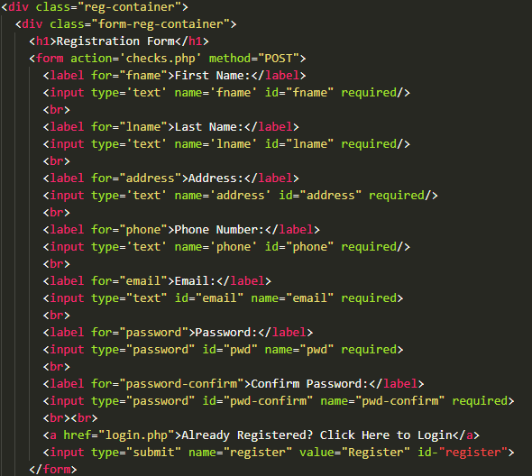

Registration HTML code above / “checks.php” code below

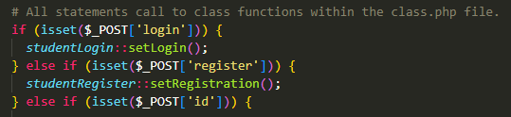



Website landing page above / registration page below

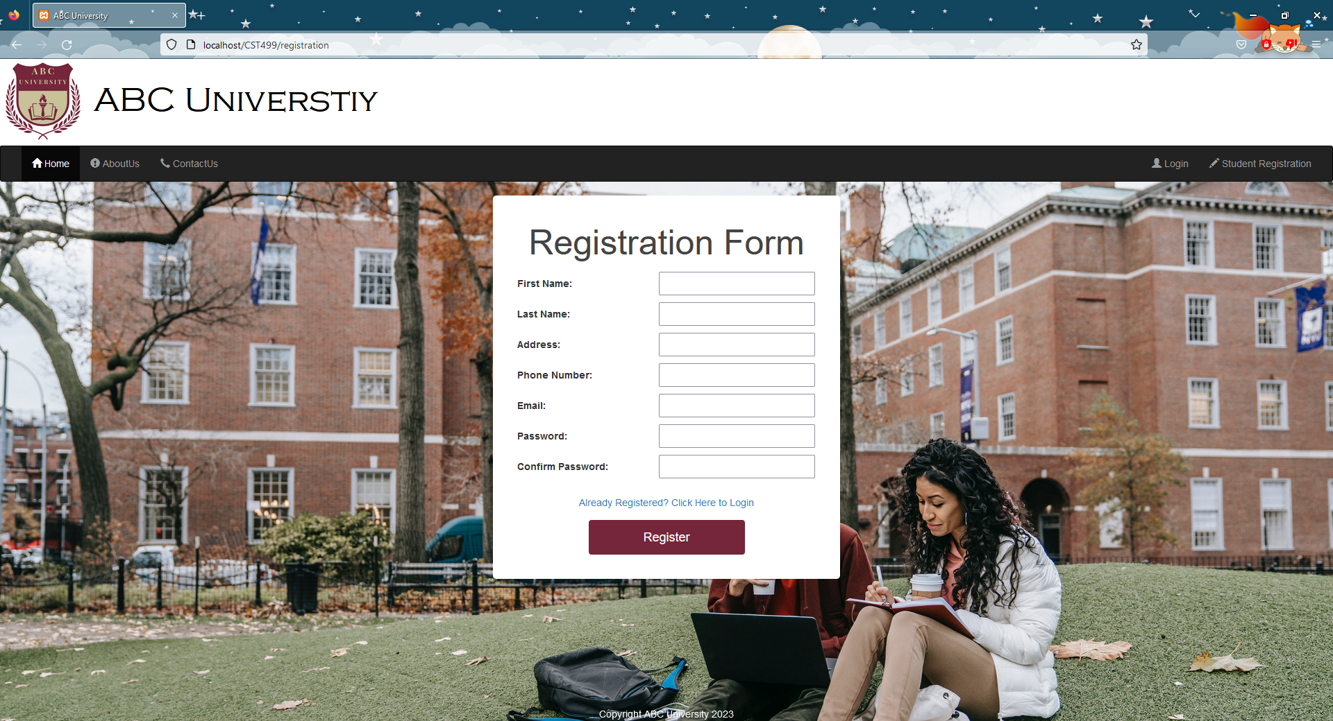

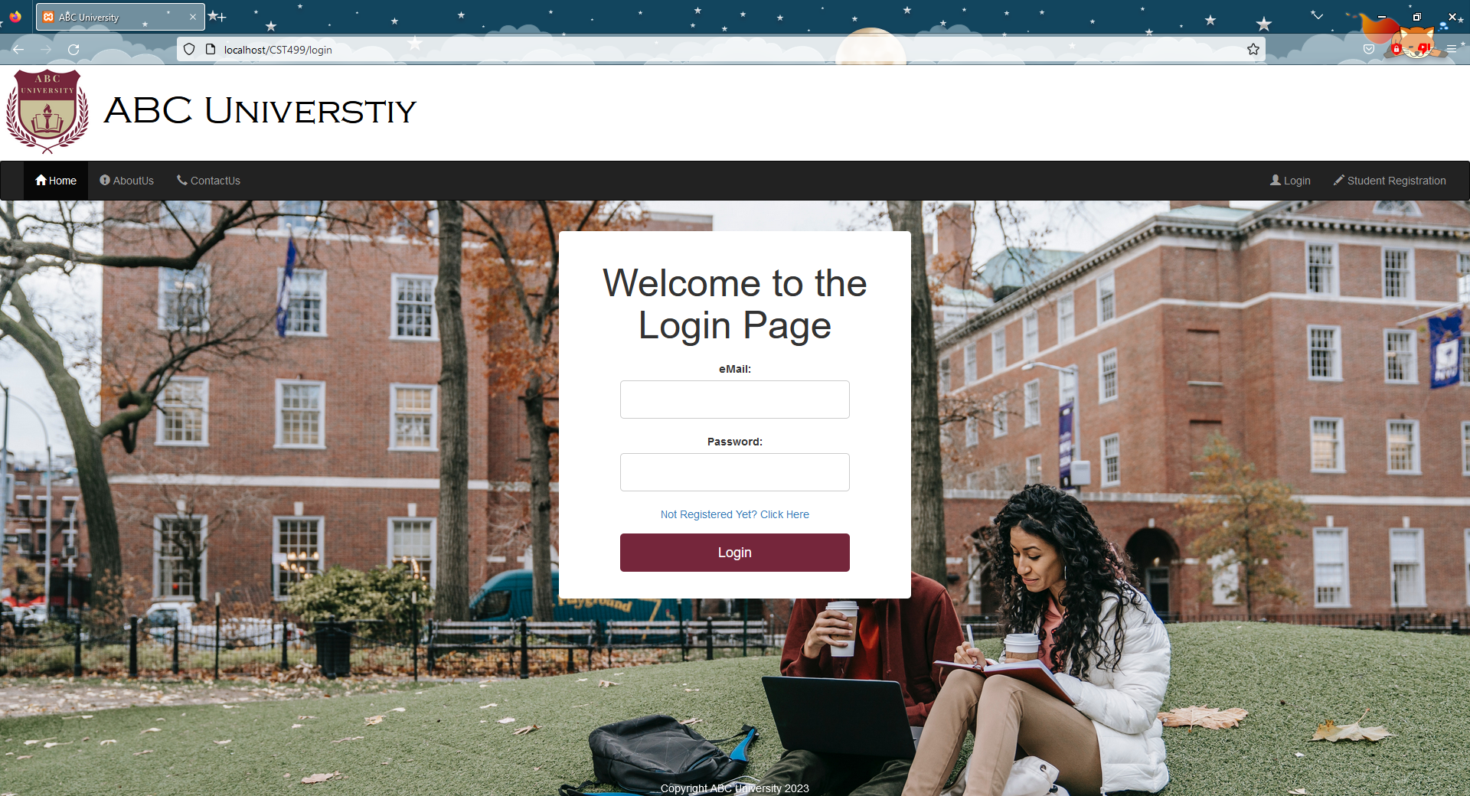

Login page above

**Conclusion**

Preparing the key technologies required to create a dynamic website that connects to a MySQL database is an essential step in the development process. By properly setting up a web server, database management system, and programming language, developers can create a website that is able to interact with a database and provide users with a more interactive and personalized experience. Whether using Apache, Nginx, MySQL, JavaScript, or PHP, it is important to carefully consider the tools and technologies being utilized in order to build a successful dynamic website that can effectively connect to a MySQL database.

**References:**

Connolly, R., & Hoar, R. (2018). [Fundamentals of web development](https://ashford.instructure.com/courses/106385/modules/items/5401052) (2nd ed.). Pearson.

Mikoluk, K. (2013, September 18). XAMPP tutorial: How to use XAMPP to run your own web

server [Blog post]. Retrieved August 25, 2022 from https://blog.udemy.com/xampp-

tutorial

*PHP: mysqli_connect - Manual*. (n.d.). https://www.php.net/function.mysqli-connect